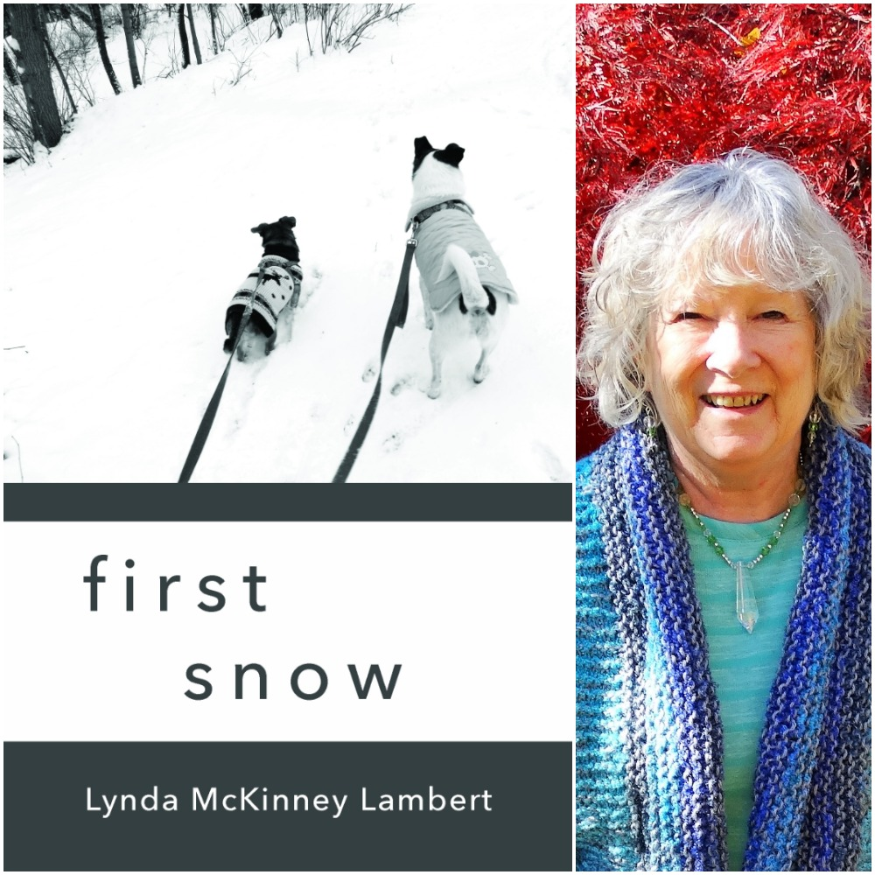

Dear Friends and Supporters of Lynda McKinney Lambert

Finishing Line Press - Pre-Orders Information

first snow
is my collection of 30 wintry-themed poems

From Sept. 8 - November 8th – Pre-Publication Orders will be received.

Your ORDER, will help determine how many chapbooks will be published by Finishing Line Press. This is the most important time to order your chapbooks and you will save on shipping charges by pre-ordering now.

My first chapbook publication is a celebration of the beauty of our created world.

This is so important to me because FLP is a small press, and this is how they determine the press run for the chapbook, first snow, that can only be purchased from FLP website or via mail order.
It will be available on amazon after January 3, 2020.

Visit the website for more information or for ordering:
https://www.finishinglinepress.com/product/first-snow-by-lynda-mckinney-lambert/

Thank you, in advance, for your support of my writing. It is thrilling for me to hear from readers who have purchased my books over the past 17 years since my first book was published. Your positive feedback is a blessing! I think that first snow, would be a wonderful “Beginning-of-the-Year” or “Valentine’s Day” gift to someone you love!

